**Zen Class Queries Documentation**

CREATE DB

**Creating required Collections**

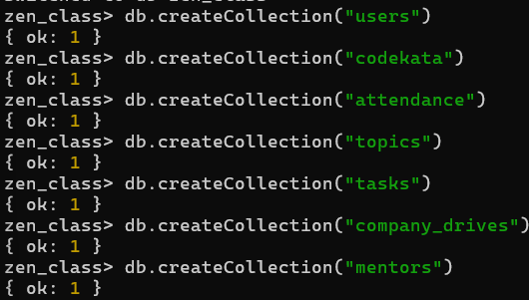

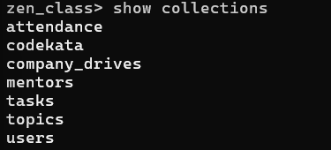

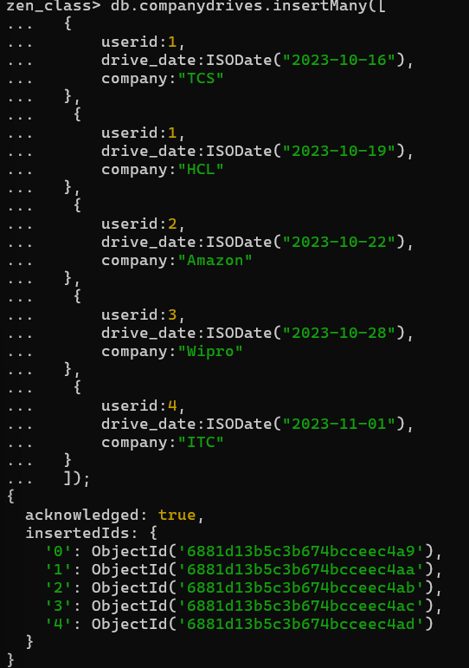

**Inserting Data in the comapnydrives collection from**

**comapnydrivesDB.txt file.**

**Inserting Data in the Codekata collection from CodekataDB.txt file.**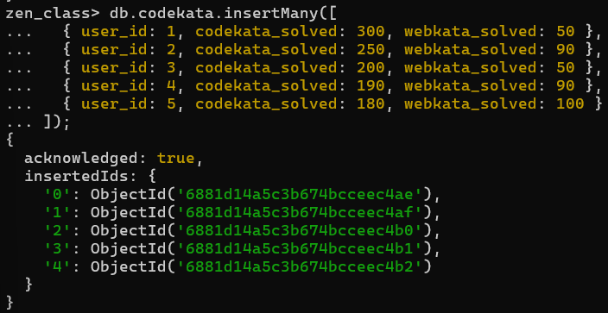

**Data inserted to the attendance collection using the attendanceDB.txt file.**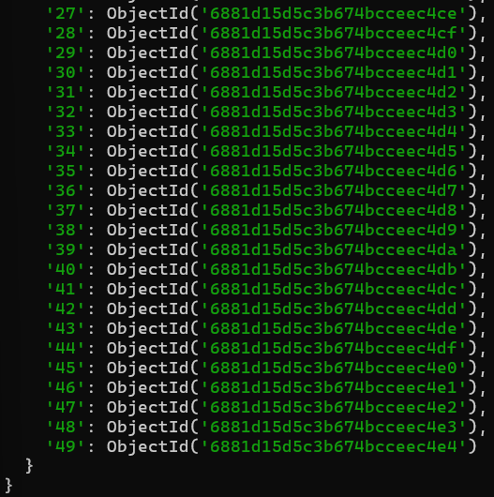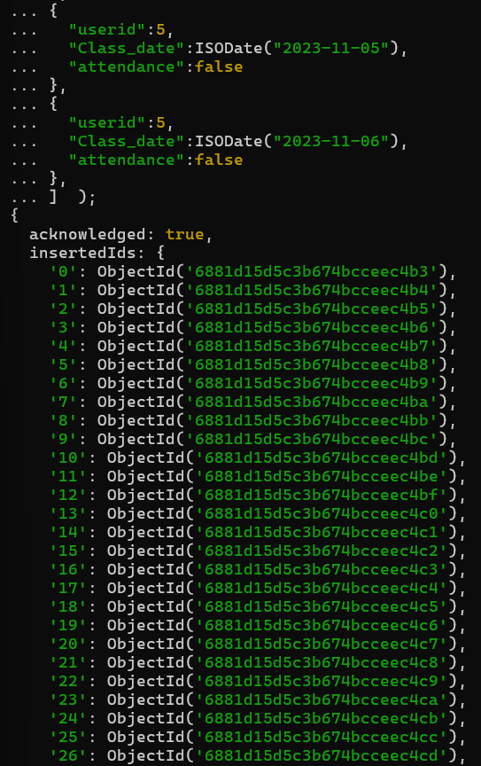

**Inserted data into the mentor collection using the mentorDB.txt file**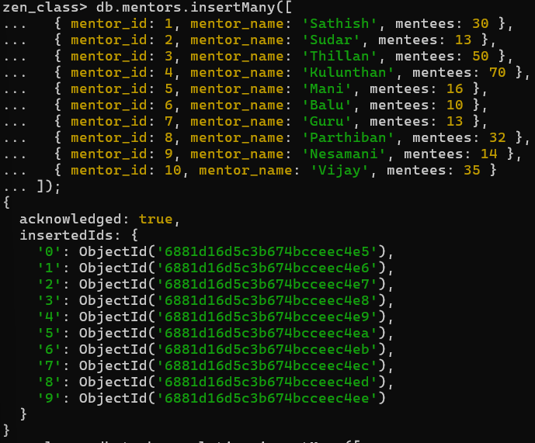

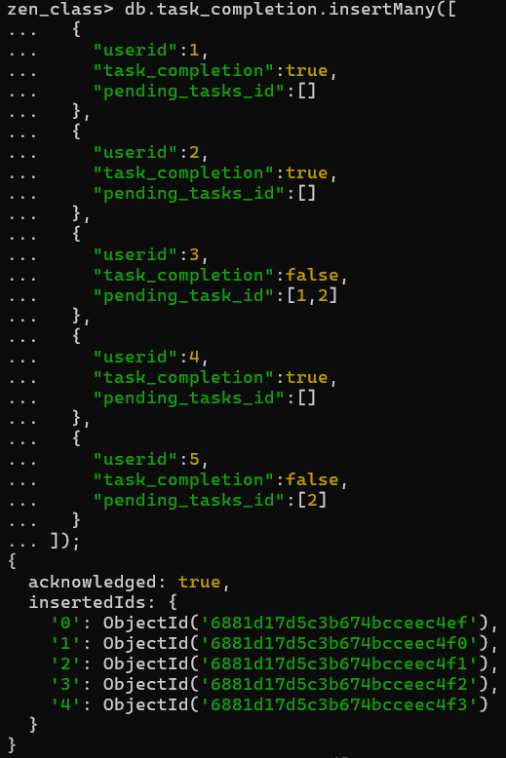

**Inserted data into the task_completion collection:**

**Inserted data into the tasks collection:**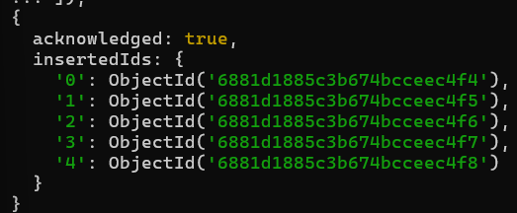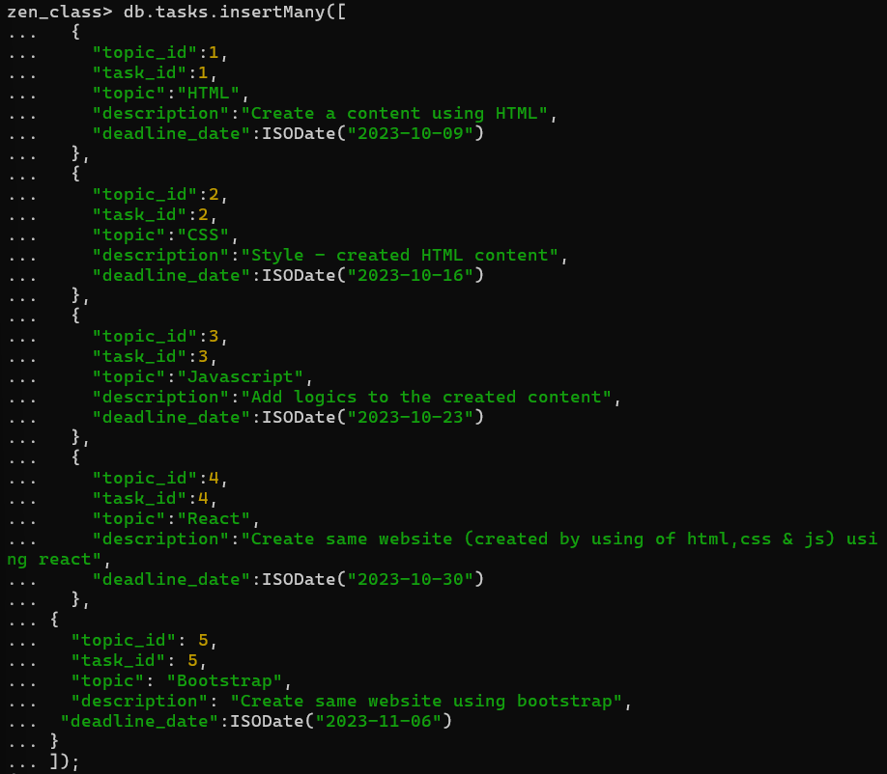

Inserted data into the topics collection: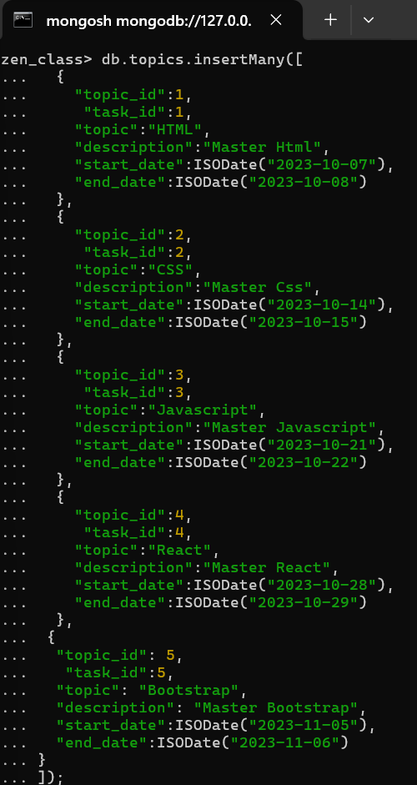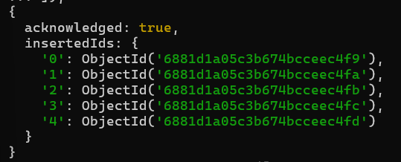

**Inserted data into the users collection:**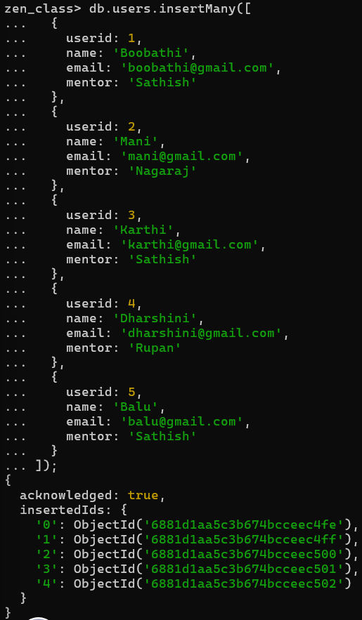

**Query 1: Find all the topics and tasks which are taught in the month of October**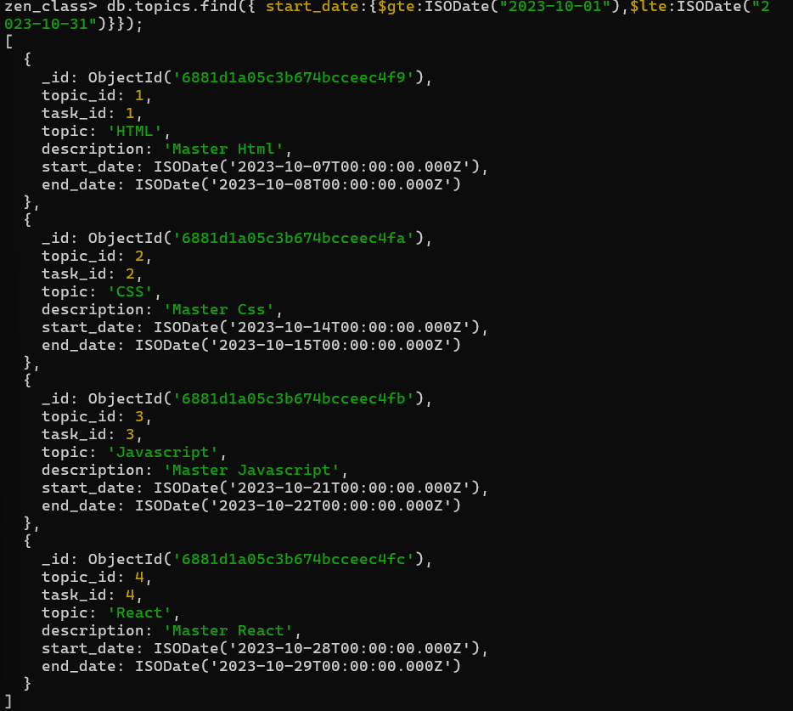

**Query 2: Find all the company drives which appeared between 15 Oct 2023 and 31 Oct 2023** 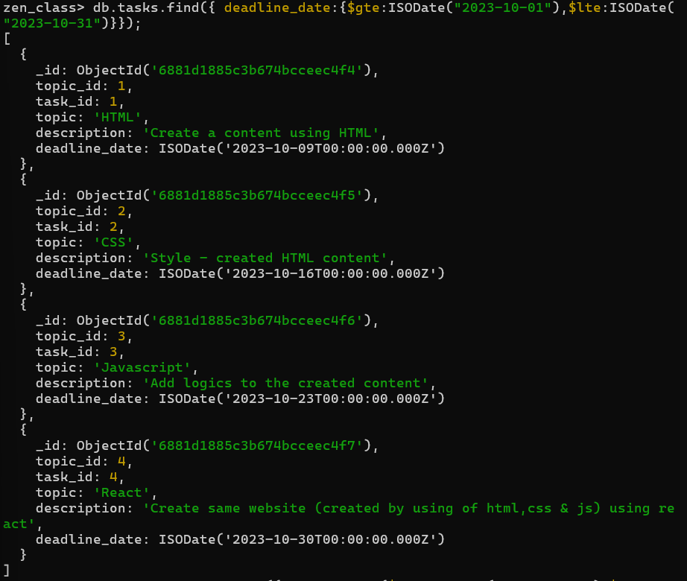

**Query 3: Find the number of problems solved by the user in codekata**

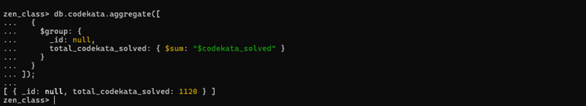

**Query 4: Find all the mentors who have mentee count more than 15**

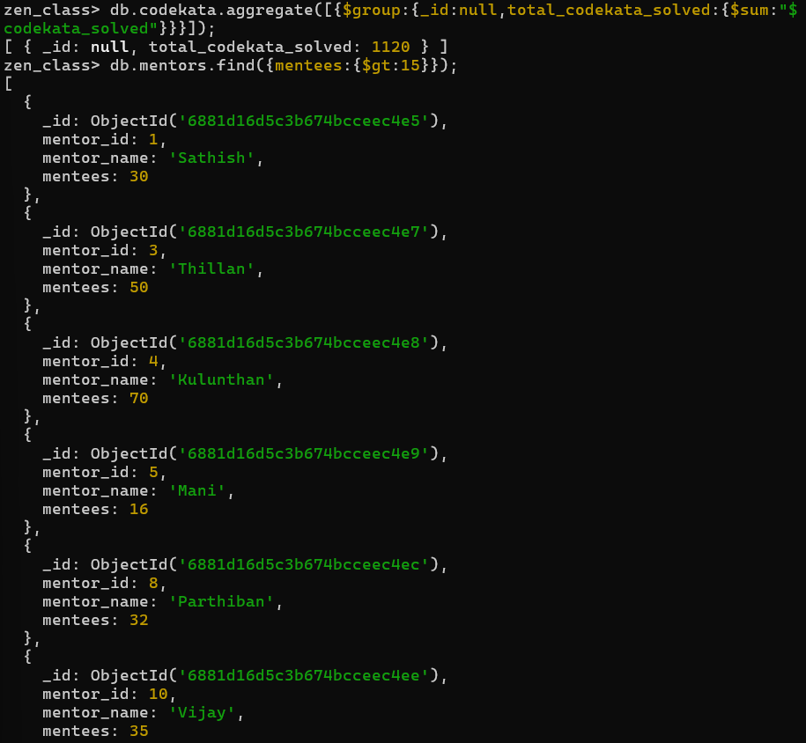

**Query 5: Find the number of users who are absent and task is not submitted between 15 Oct 2023 and 31 Oct 2023**

Run these step-by-step using MongoDB Shell inside Compass (or your application).

**Step 1:** Find absentees 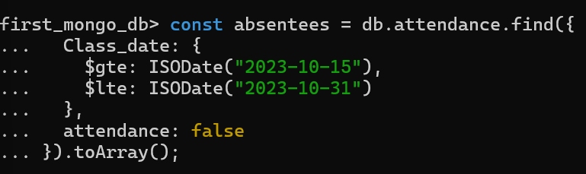

**Step 2:** Extract distinct user IDs from absentees



**Step 3:** Find users from that list who didn't submit tasks

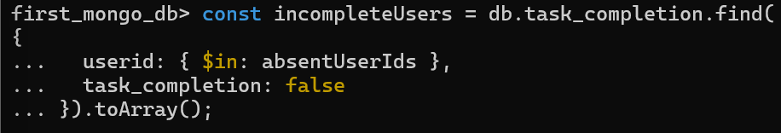

**Step 4:** Count the users



**Conclusion:**

This project showcases how MongoDB Shell can be effectively used to handle and explore Zen Class educational data. Through shell-based operations, we designed and executed five insightful queries focused on session planning, placement drives, problem-solving trends, mentor performance, and user engagement. The outcome highlights the MongoDB Shell’s capability as a robust backend tool for data-driven analysis in learning environments.